4. Load the Jing’s Face in the MeshLab

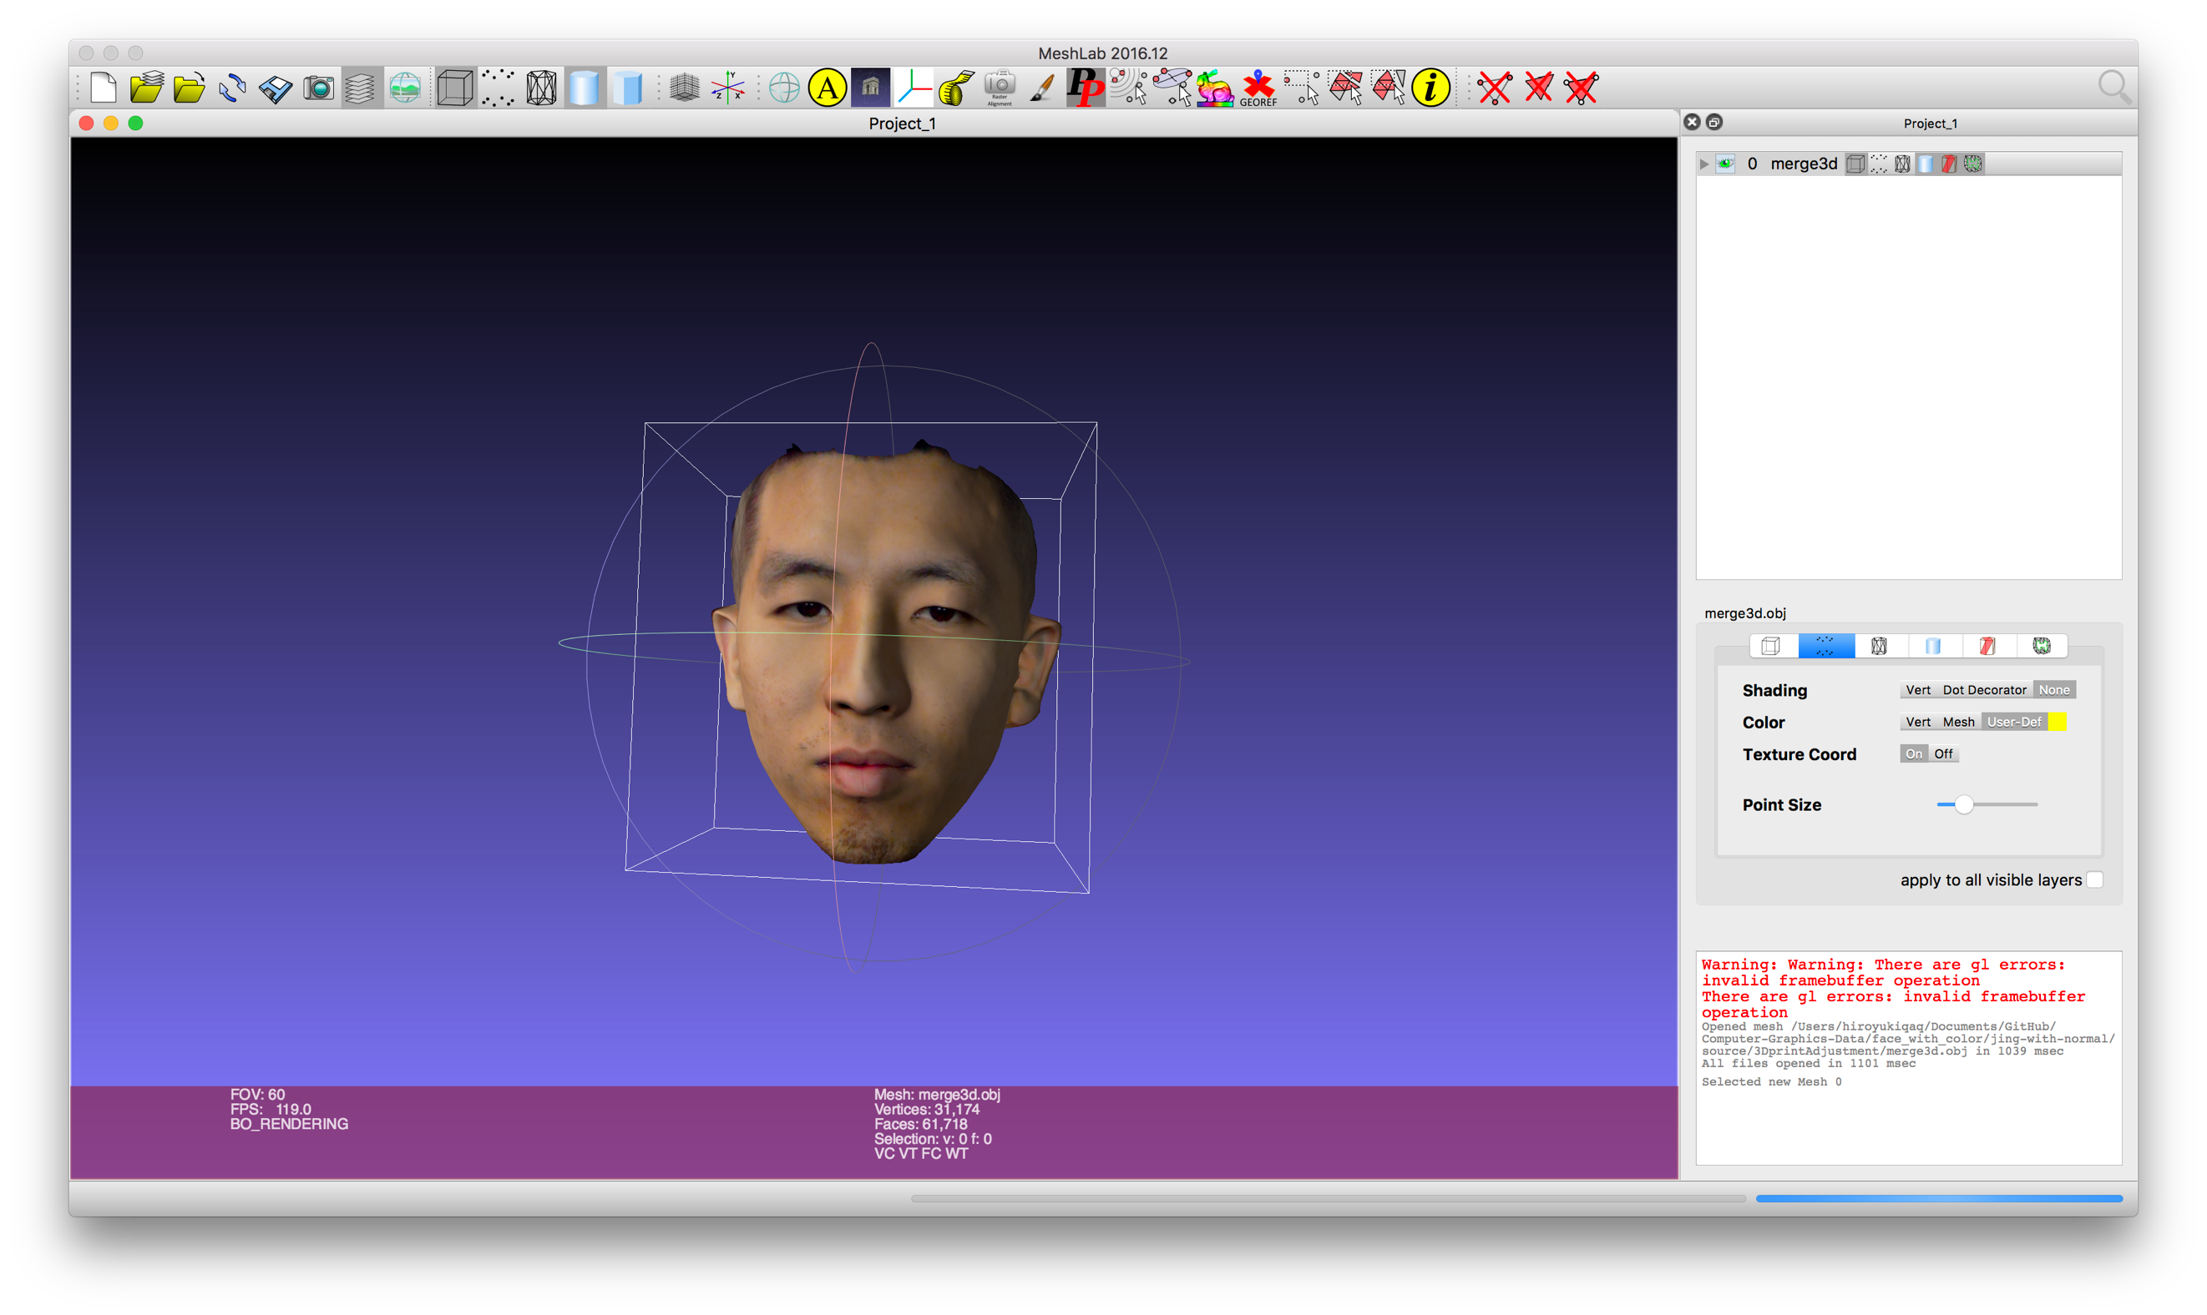

5. Load the Jing’s Face into the Sketchfab

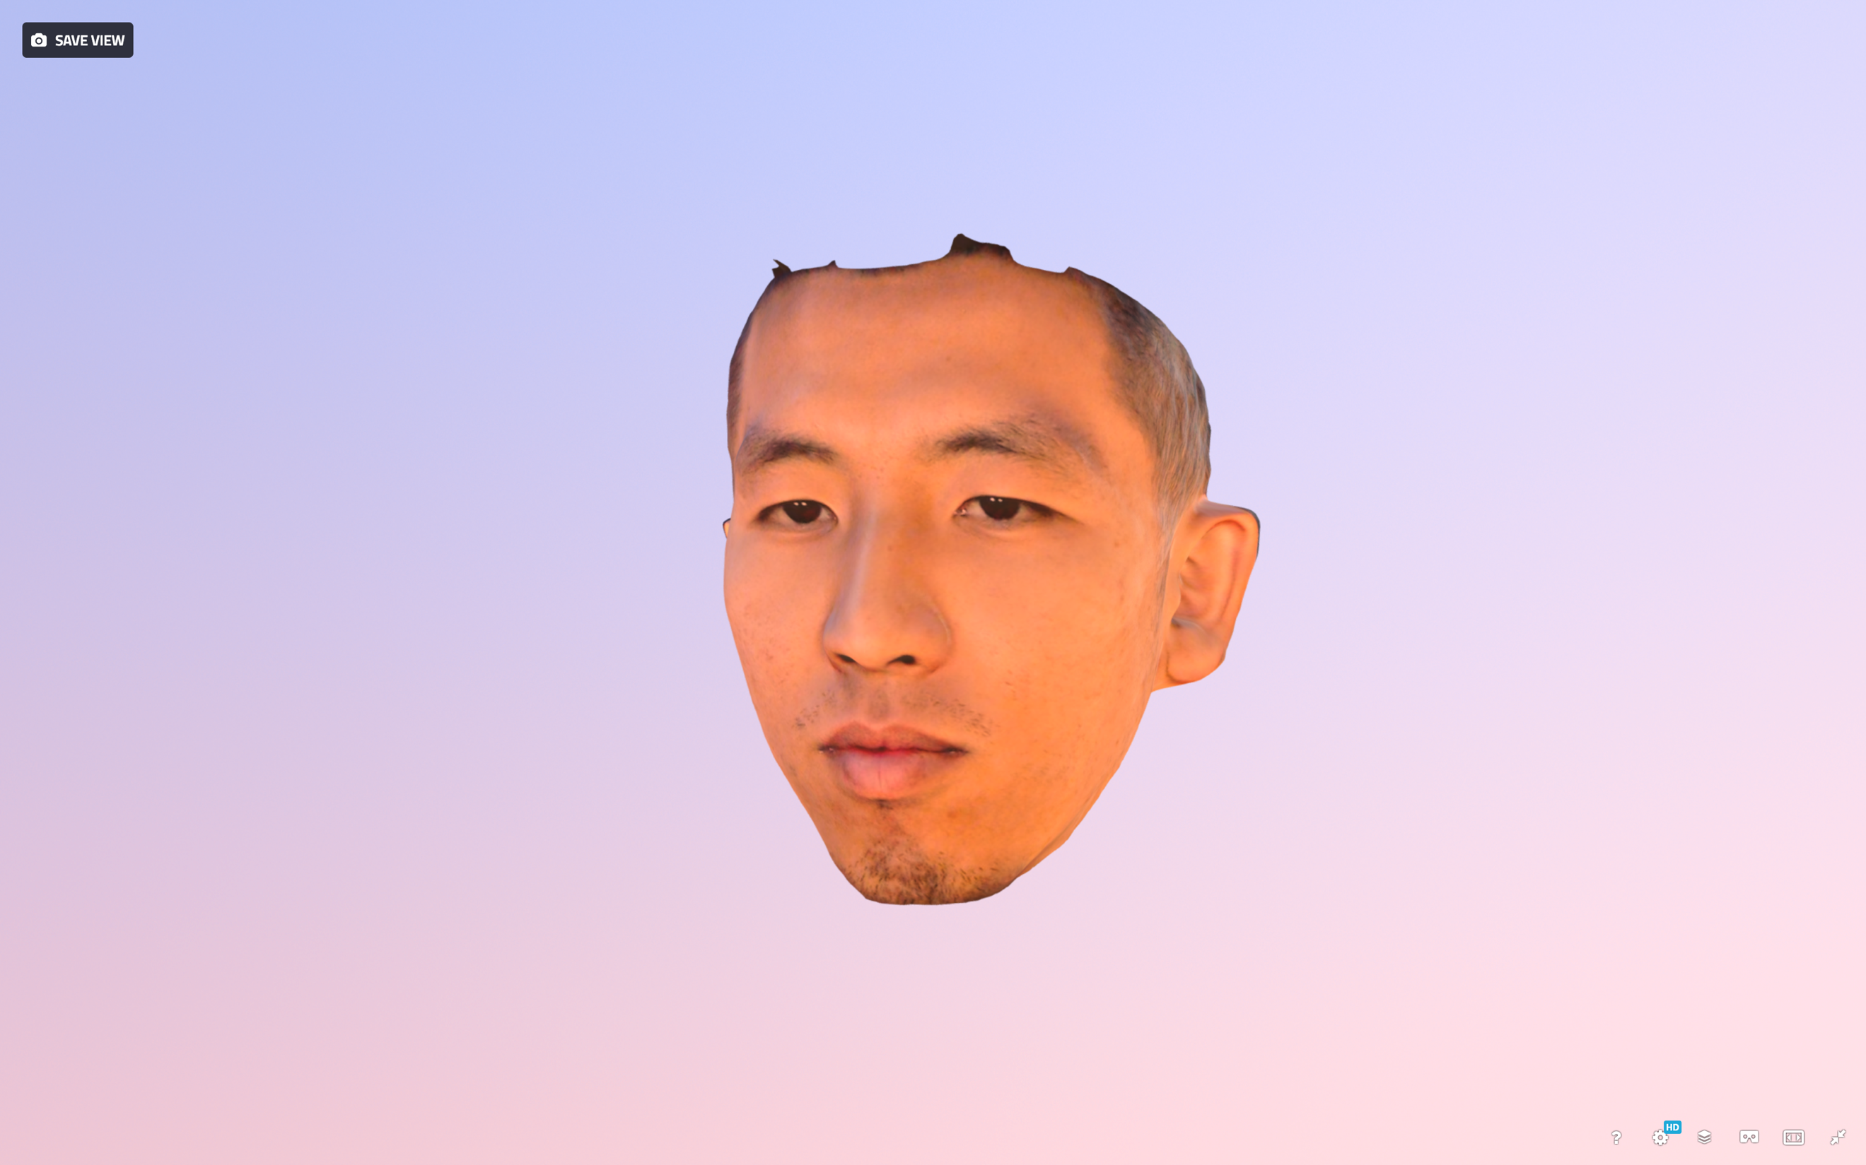

Link: <https://sketchfab.com/models/23bbac53f8d54abfbbbc26f49ffb2943>

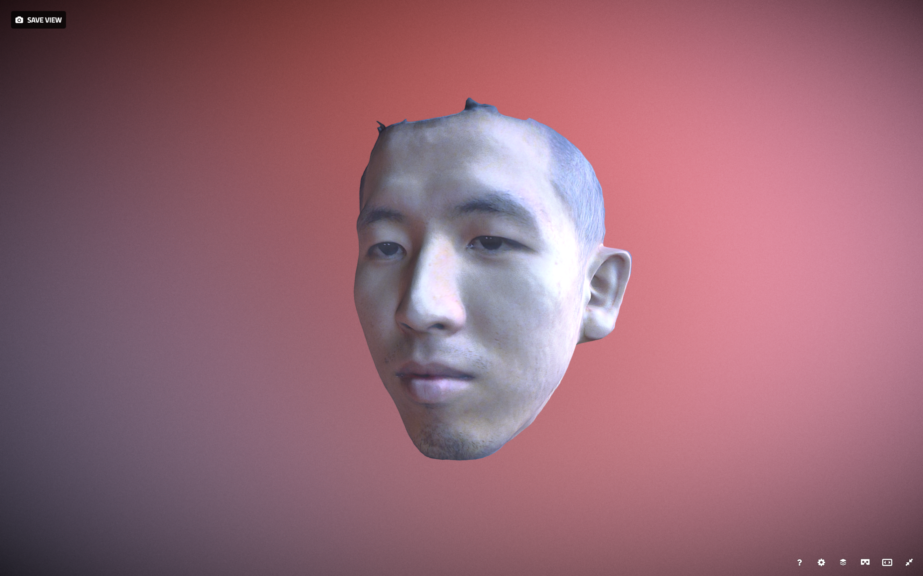

Link: <https://sketchfab.com/models/977abdab6d83422f9d6a7a487fe6fa48>

6. Load the James Face into the Sketchfab

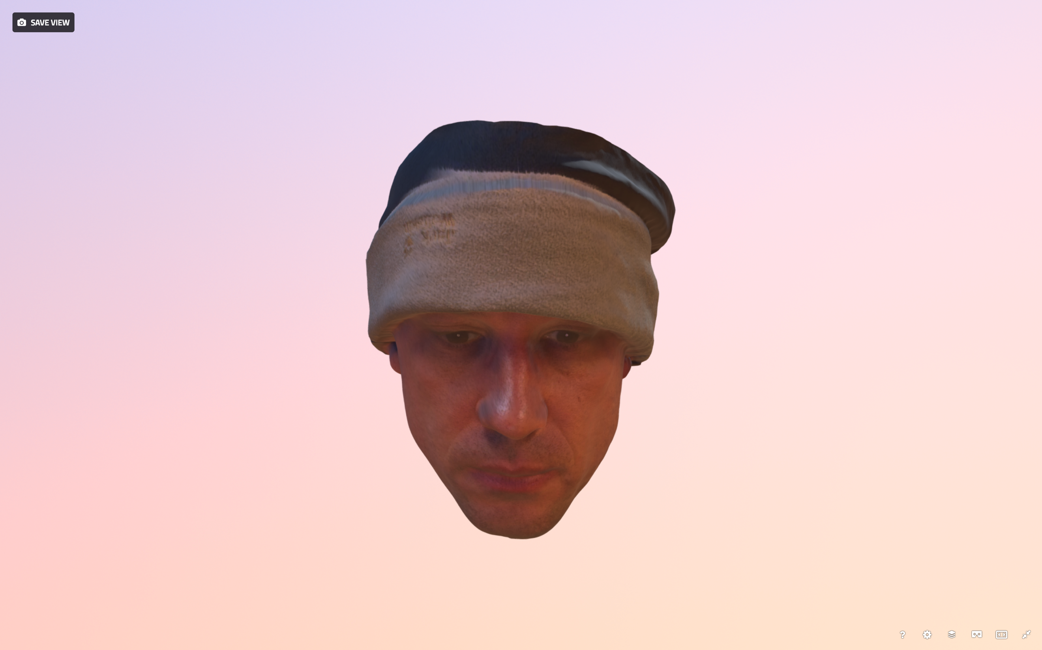

Link: <https://sketchfab.com/models/63c3e6830d2d45e49c5a6cee8558b7b3>

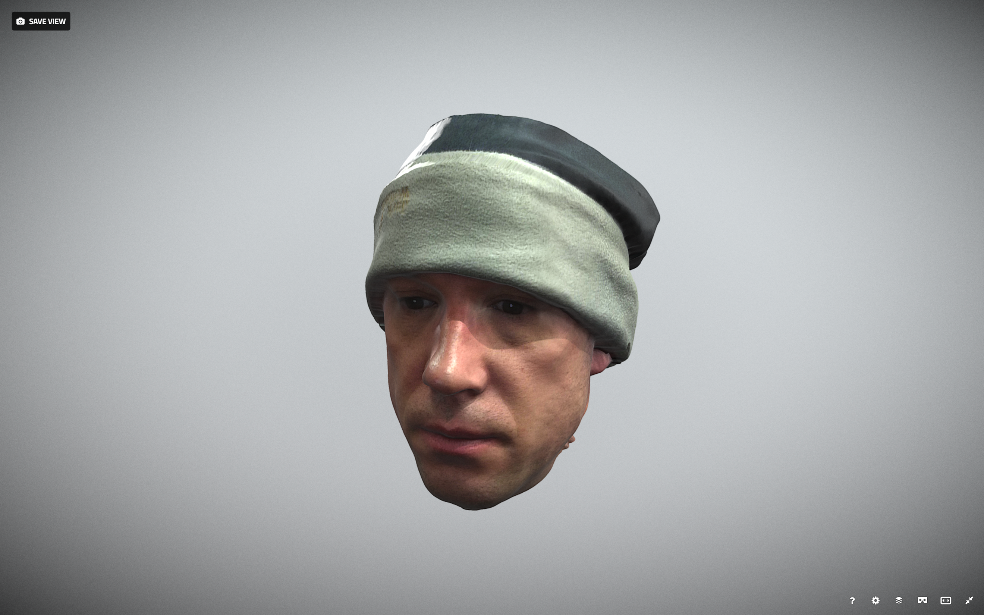

Link: <https://sketchfab.com/models/cb5670e7aef74040aff79bfd105d50c1>

11.

<https://cdn.rawgit.com/HiroyukiQAQ/Computer-Graphics/master/Li%20Yunzhe-GL5/GL5_byLi.html>

12.

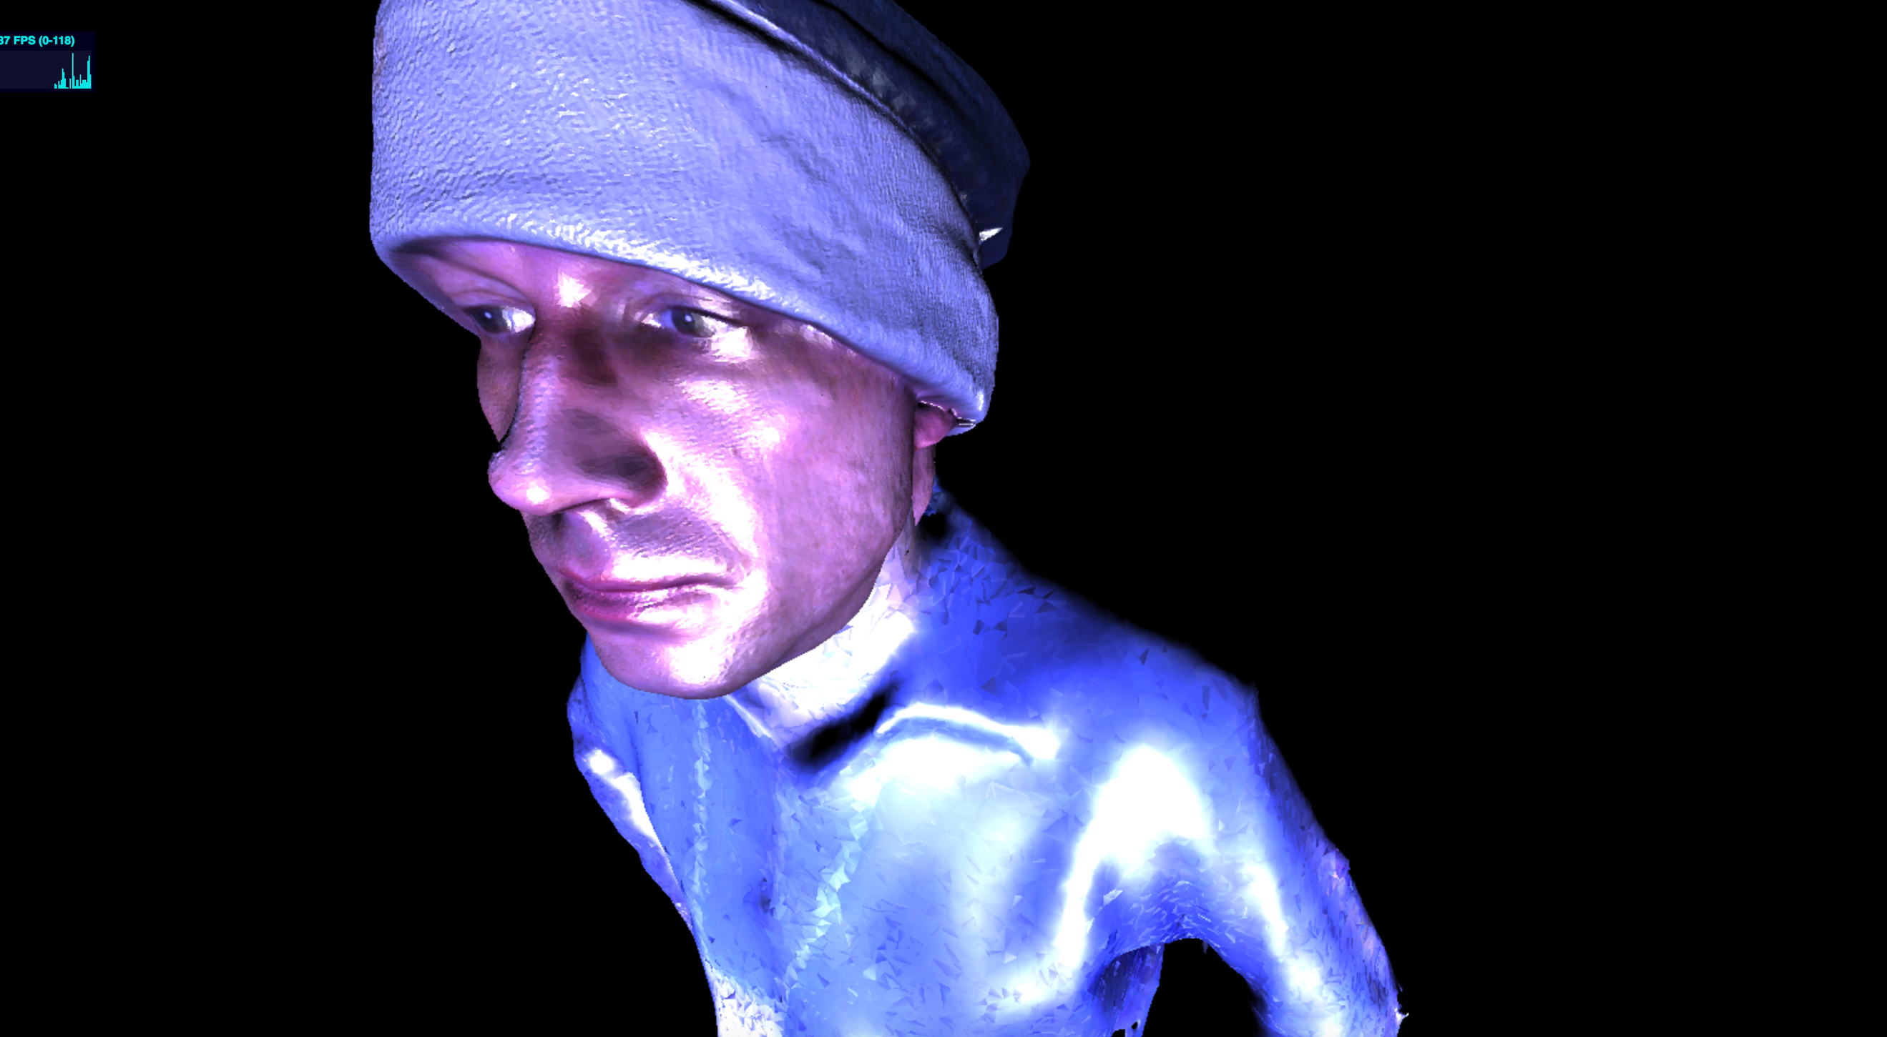

13.

On Macbook

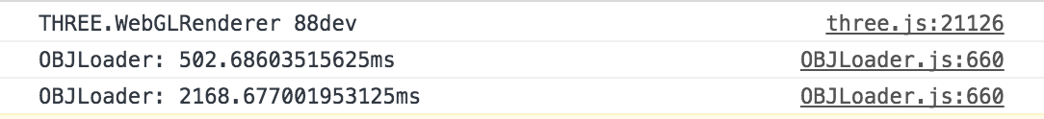

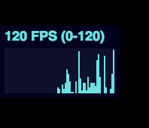

On iPhone 6s(almost 1 min)



On iPad Air 2(almost 1 min, corrupt several times)

